**Path based routing using traffic manager**

The architecture that is intended to be achieved in given below:

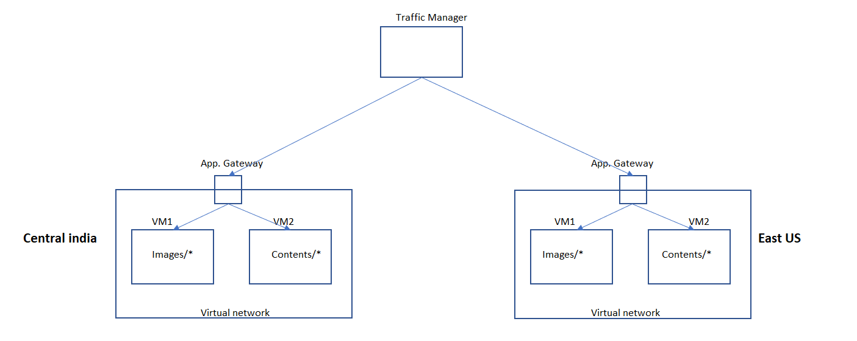

Create VM1 and VM2 in Central India zone:

**VM creation (VM1India) validated screenshots:**

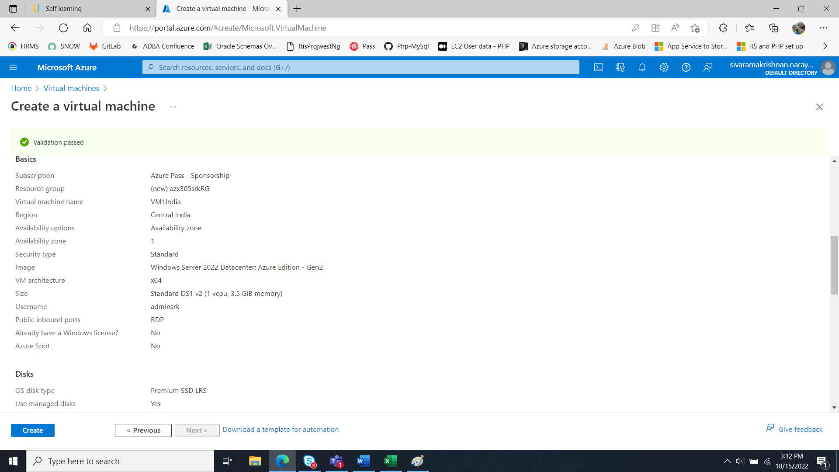

**Repeat the above process for VM2 (Central India, VM1 & VM2 in East US)**

As of now the public input port 3389 is open to login to the VMs and install the IIS and host the relevant webpage.

After this process the inbound port to all the VMs will be blocked to protect from other exclusive access.

Removed the Inbound port access from inbound rules:  
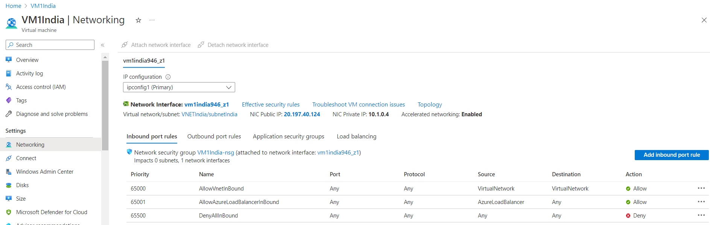

Continue the above process for all the VMs in both the regions:

Create application gateway for India region

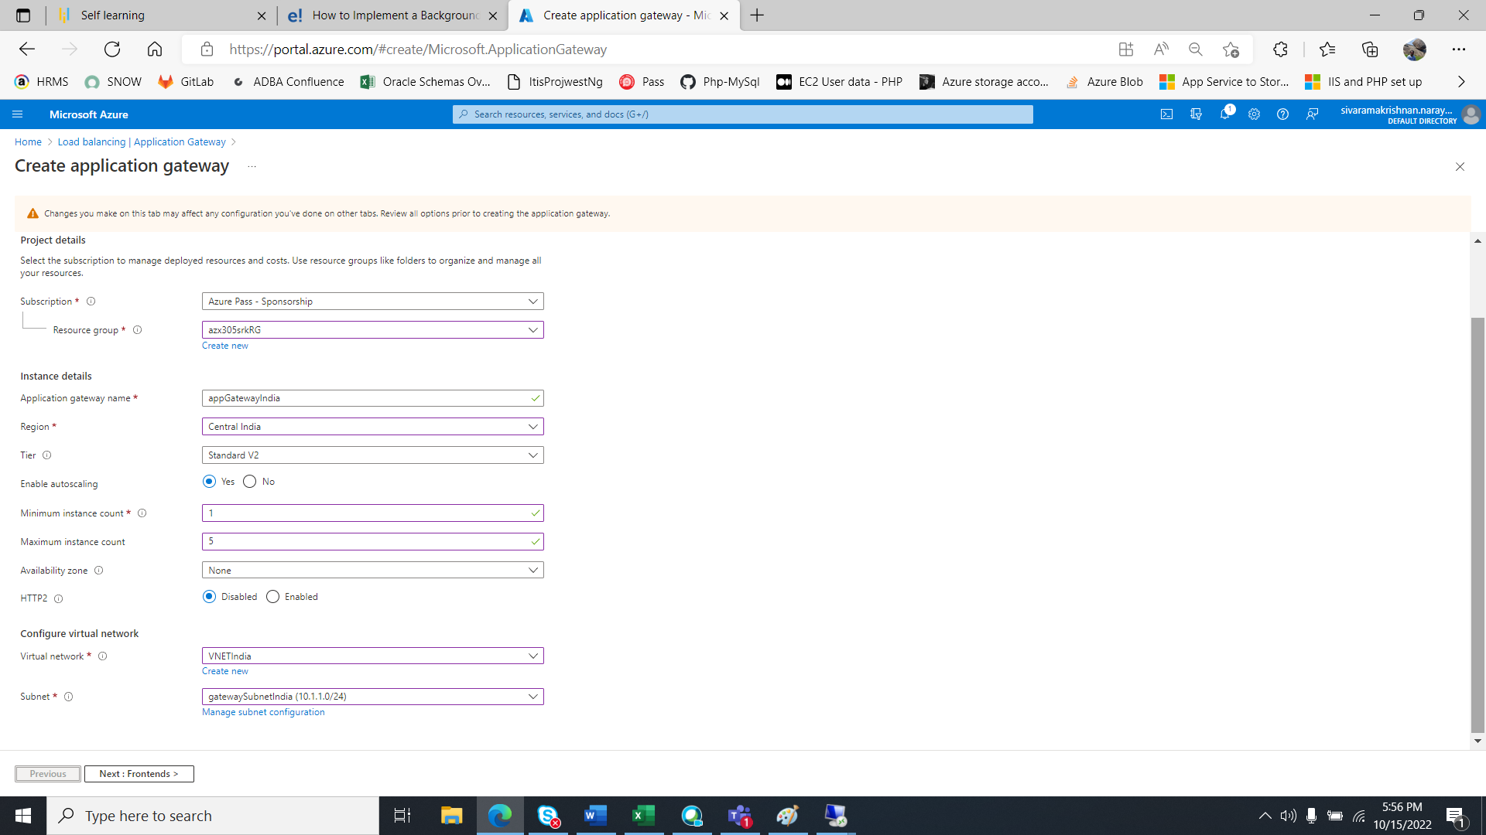

In this process create a separate subnet for application gateway.

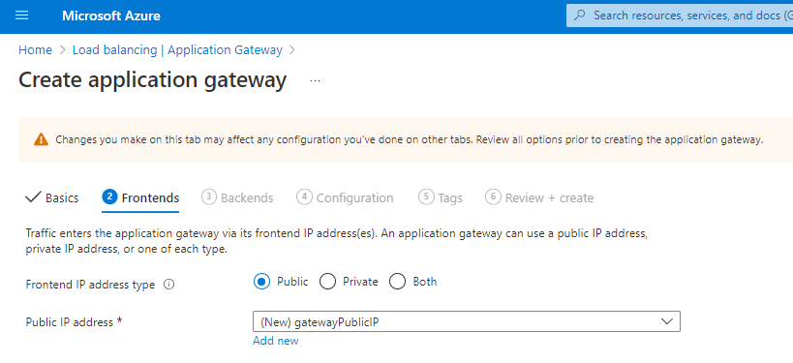

Configure back-end pool

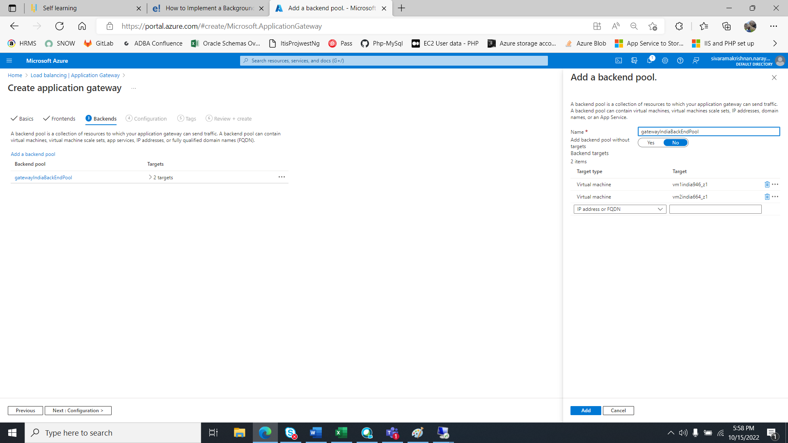

Setting Routing rules

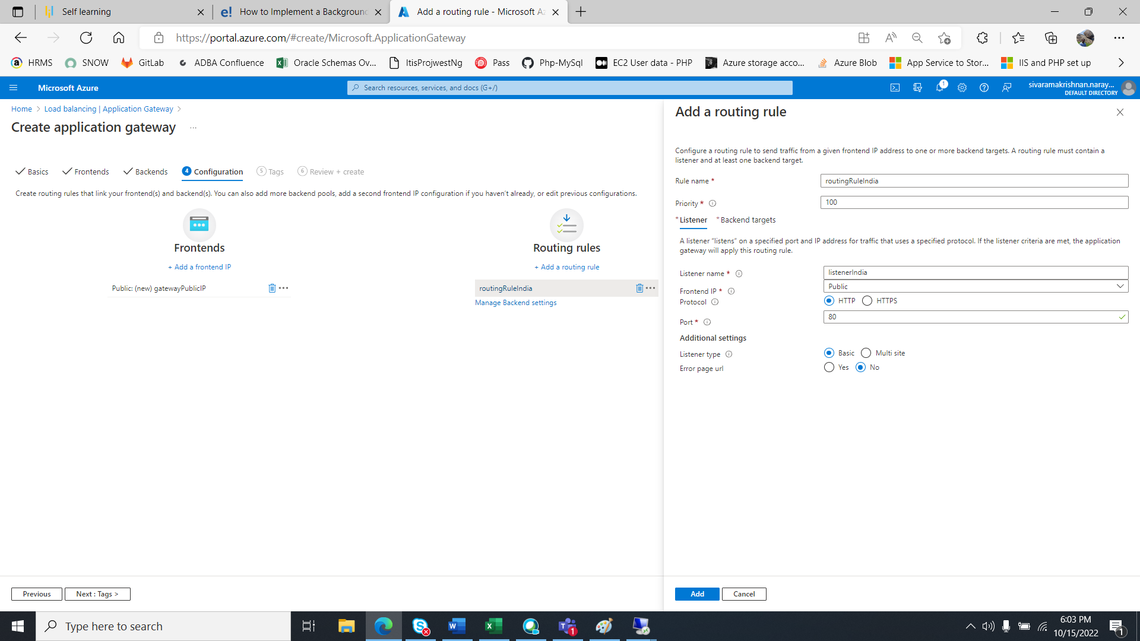

Configuring DNS (indiagate.centralindia.cloudapp.azure.com)   
for Application gateway in india region

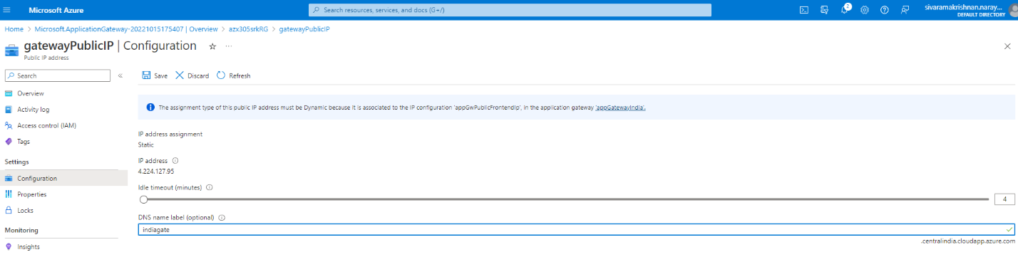

Configuring DNS (eastusgate.eastus.cloudapp.azure.com)   
for Application gateway in East US region  
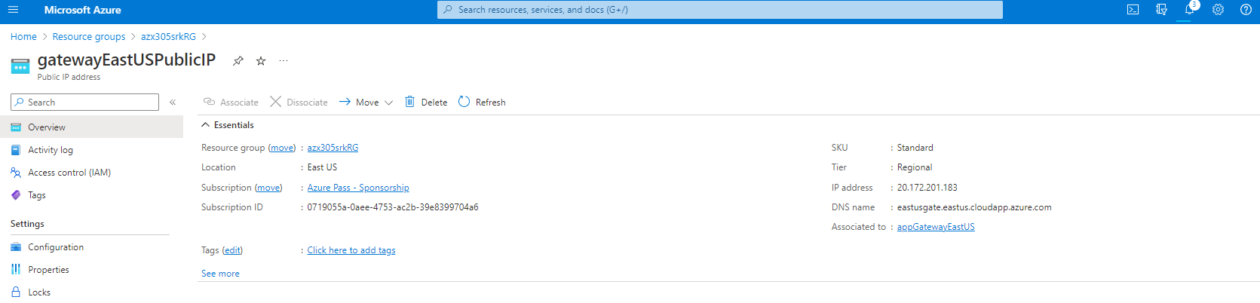

TESTING individual gateways with path based routing  
**indiagate.centralindia.cloudapp.azure.com**

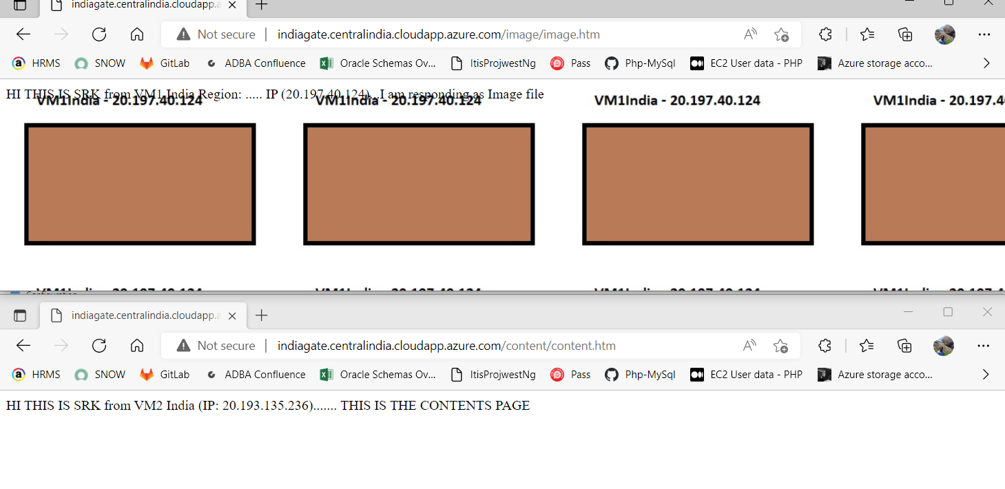

**eastusgate.eastus.cloudapp.azure.com**

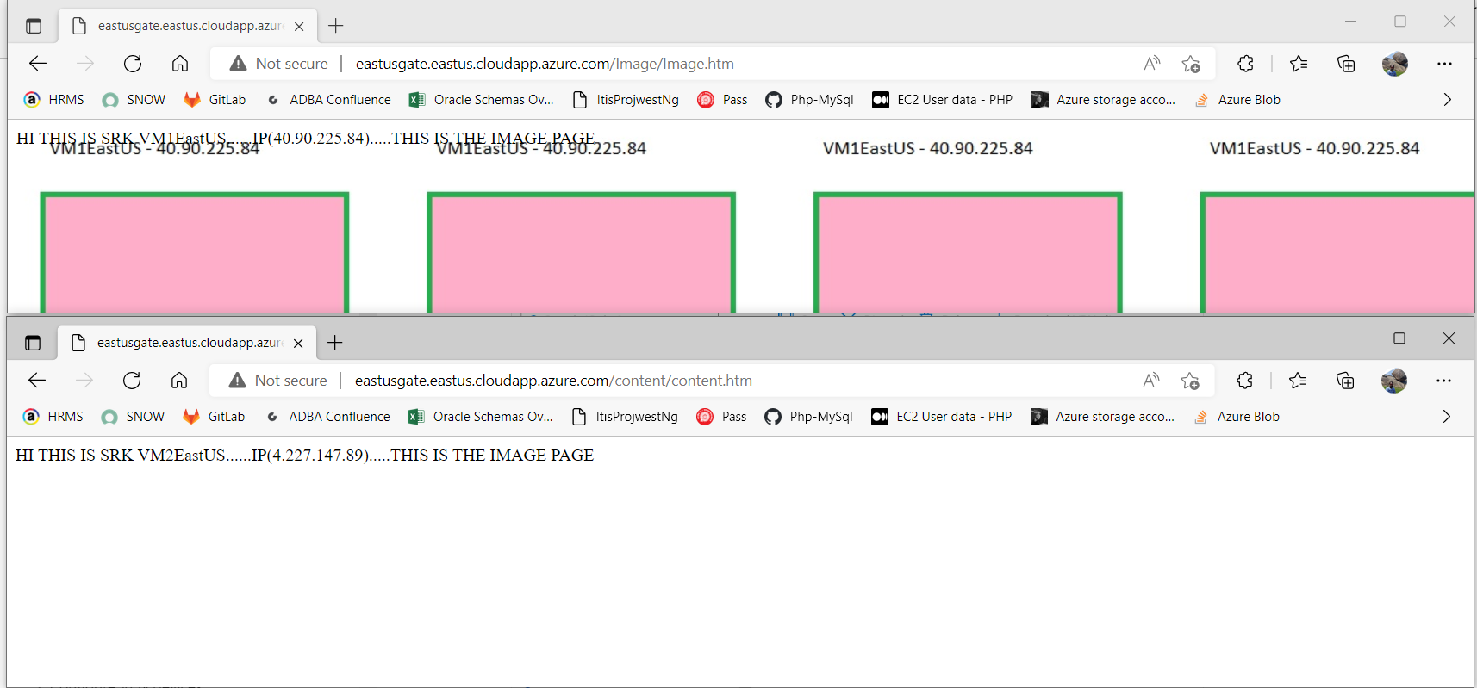

**Creating Traffic Manager and configuring the Application gateways by the routing method as “Priority”.**

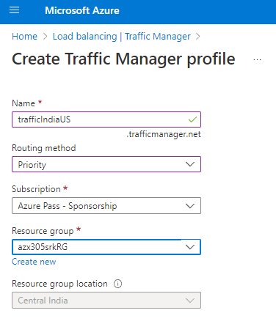

**Creating Traffic Manager end points for Application gateways**

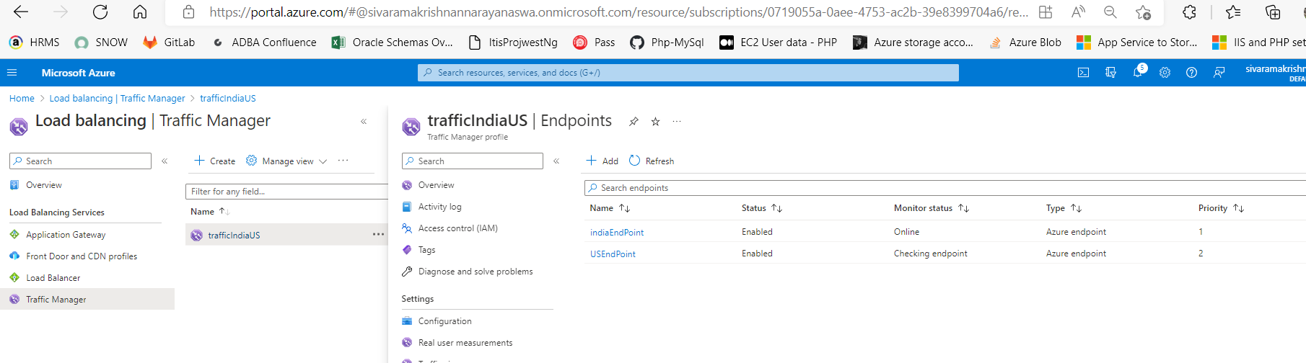

TESTING Traffic Manager routing:

**This is routing to India because the priority is set to “1”**

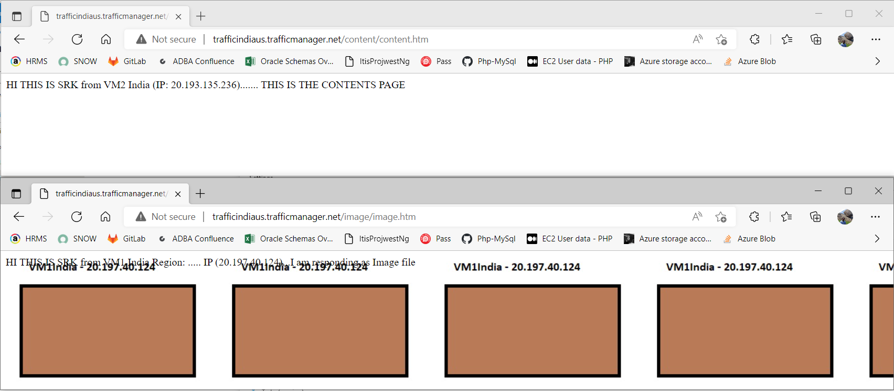

TESTING Traffic Manager routing:

**This is routing to US because the priority for India is set to “3” and US is “2”**



